R SQUARED INTUITION

Simple linear regression is build by ordinary Least Square Method where we are minimizing the sum of squares of differences of yi and yi^{cap}, i.e,we are looking at the difference, we are squaring it for all the observations and then we are counting the sum. The line that has the smallest sum will be the best fitting line or will be the simple linear regression model.
ss_{res} = SUM(y_{i} - y_{i}^{cap})²

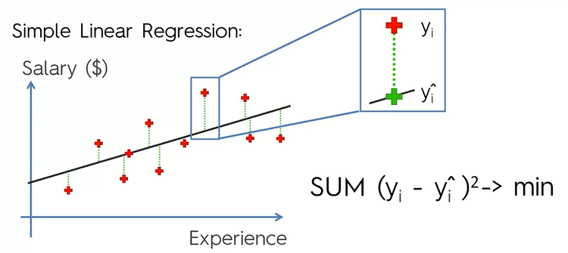

Now, instead of drawing the regression line, let us draw the average line and project our observations on this average line and then calculate the distances and square them.
ss_{total} = SUM(y_{i –} y_{i}^{cap})²

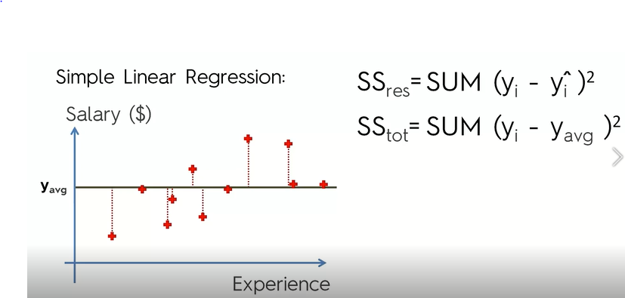
R² = 1 – ss_{res}/ss_{tot}

R² is telling us that how good is our line as compared to the average line.

In order to get the best fitting line you run a linear regression, so we minimize ss_{res}
ss_{res} decreases => ss_{res} decreases => (1-ss_{res}/ss_{tot}) increases
If ss_{res} = 0
=> your tresd line that you are modeling goes through all the records and in that case R² = 1
This is the ideal scenario.

The more R² closer to 1 the better

R² can be negative( if ss_{res} fits your data worse than your average line.
Normally it is between 0 and 1.

